# AutoTest Studio Getting started tutorials 9: Send test report via email

AutoTest Studio has a built-in mail sending module, which can automatically send the test report of the task to the specified mailbox after the task runs.

**Configure email parameters**

The configuration is divided into three parts, as shown in the figure below, from top to bottom, the configuration of the sender is in turn, the middle part is the header format of the email body, and the lower part is the recipient's email address. Multiple recipient addresses can be used.

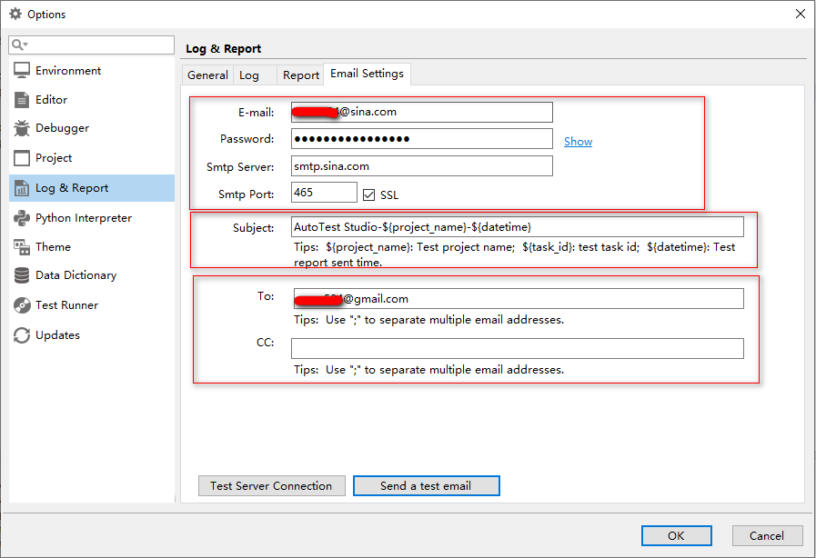

**Test configuration**

After we have completed the parameter configuration of the mailbox, we can click "Send a test email" to check whether the configuration information is correct. As shown in the figure above, we open the received mailbox and receive a subject with the subject "AutoTest Studio Mail Test" s mail.



**Carry log**

The report sent by AutoTest Studio does not carry log files by default, because log files are often relatively large, which may cause transmission failure. If your mailbox supports larger attachments, you can set the email to carry log files. The settings are as follows.

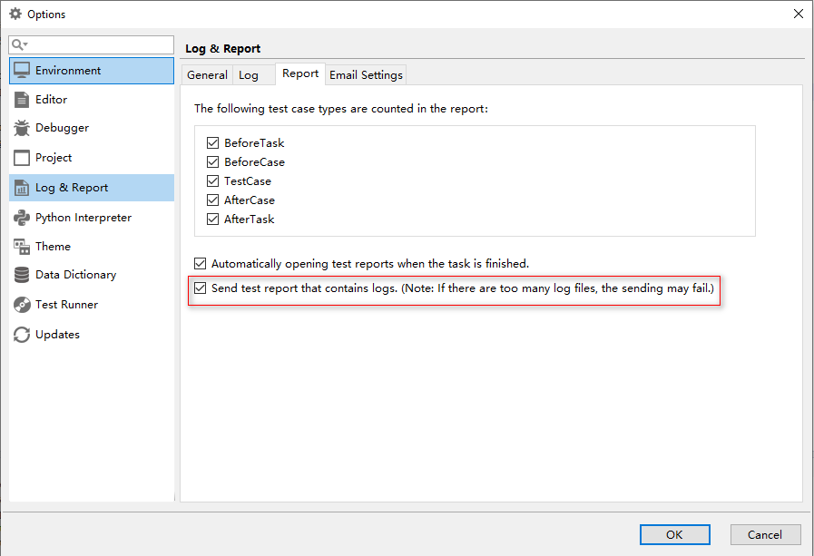

**Send a report after the task is over**

The function of sending test report can only be used when it is running in "Advanced Run" mode. As shown in the figure below, check "Send test report by email" and click "Start" to run the task.

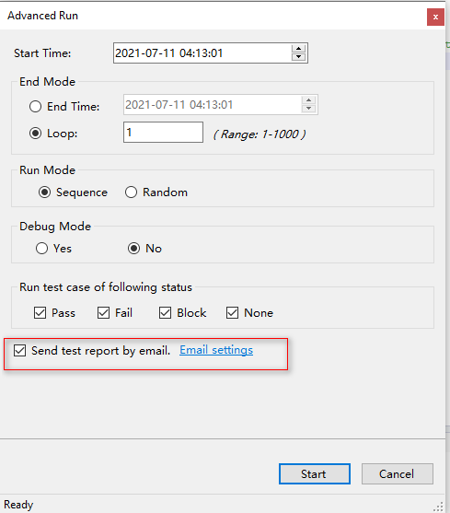

After the task is completed, we check the receiving mailbox and we can see that we have received an email with the subject "AutoTest Studio-Demo-20210711041552". The attachment is the compressed package of the test report and log. The body of the email is as follows.

